MySQL Database Assessment
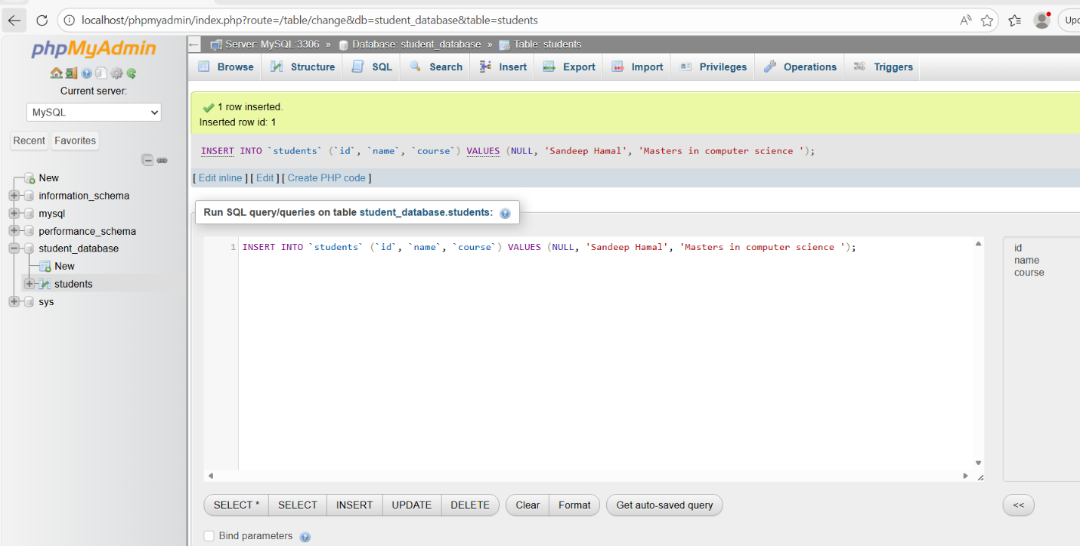
The WAMP server was started and all services were allowed to run successfully.
phpMyAdmin was opened by entering the following address into a web browser:
http://localhost/phpmyadmin
The login details used were:
Username: root
Password: blank
Server: MySQL
After logging in successfully, the left-hand side of phpMyAdmin and the Databases tab were checked.
The databases shown were:
- information_schema
- mysql
- performance_schema
- phpmyadmin
- sys
- student_database
A new database called student_database was also created.
Inside this database, a table called student was created with the following fields:
- id
- name
- course
This confirms that MySQL was accessed through phpMyAdmin and that databases were successfully viewed and created.

